**PIZZA SALES SQL QUERIES**

**A. KPI’s**

1. **Total Revenue:-**

select sum(total_price) as Total_Revenue from pizza_sales;

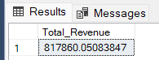

1. **Average Order Value:-**

select sum(total_price)/count(distinct (order_id)) as Avg_Order_Value from pizza_sales;

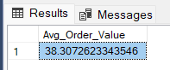

1. **Total Pizzas Sold :-**

select sum(quantity) as Total_Pizza_Sold from pizza_sales;

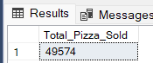

1. **Total Orders :-**

Select count (distinct(order_id)) as Total_Orders from pizza_sales;

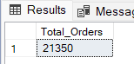

1. **Average Pizzas Per Orders:-**

Select cast(cast(sum(quantity) as decimal(10,2))/

cast(count (distinct(order_id)) as decimal(10,2) ) as decimal(10,2)) as Avg_Pizzas_Per_Orders from pizza_sales;

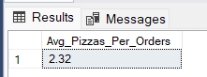

**B. Daily Trends for Total Order**

Select DATENAME(DW,order_date) order_Day,

Count(distinct(order_id)) as total_orders

from pizza_sales

Group by DATENAME(DW,order_date) ;

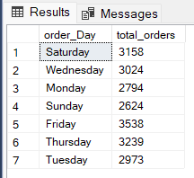

**C.Hourly Trend for Total Pizzas Sold**

Select DATEPART(Hour,order_time) as order_hour,

Sum(quantity) as Total_Pizza_Sold

from pizza_sales

Group by DATEPART(Hour,order_time)

Order by DATEPART(Hour,order_time);

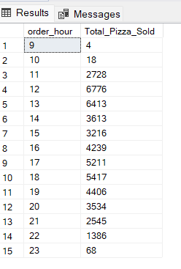

**D.Weekly Trends for Total Orders**

Select DATEPART(ISO_WEEK,order_date) as week_number,

YEAR(order_date) as Order_year,

Count(distinct(order_id)) as Total_Orders

from pizza_sales

Group by DATEPART(ISO_WEEK,order_date),YEAR(order_date)

Order by DATEPART(ISO_WEEK,order_date),YEAR(order_date);

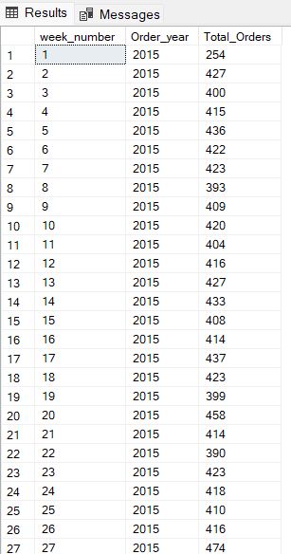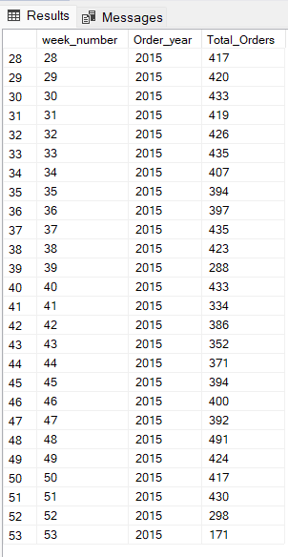

**E. Percentage of Sales by Pizza Category**

Select pizza_category,Sum(total_price) as Total_Sales,sum(total_price)*100/(Select sum(total_price) from pizza_sales) as PCT

from pizza_sales

group by pizza_category

order by pizza_category;

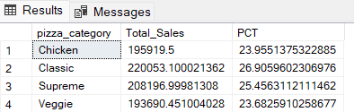

**F. Percentage of Sales by Pizza Size**

Select pizza_size,Sum(total_price) as Total_Sales,sum(total_price)*100/(Select sum(total_price) from pizza_sales) as PCT

from pizza_sales

group by pizza_size

order by PCT desc;

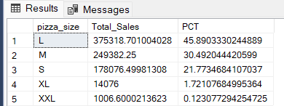

**G. Total Pizza Sold by Pizza Category**

Select pizza_category,sum(quantity)

from pizza_sales

group by pizza_category ;

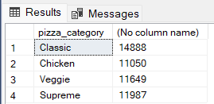

**H. Top 5 best sellers by revenue**

Select Top 5 pizza_name,sum(total_price) as Total_Revenue

from pizza_sales

Group by pizza_name

Order by Total_Revenue desc;

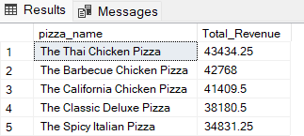

**I.Bottom 5 best sellers by revenue**

Select Top 5 pizza_name,sum(total_price) as Total_Revenue

from pizza_sales

Group by pizza_name

Order by Total_Revenue ;

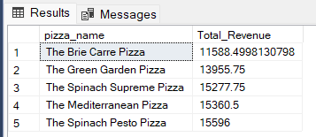

**J.Top 5 best sellers by quantity**

Select Top 5 pizza_name,sum(quantity) as total_quantity

from pizza_sales

Group by pizza_name

Order by total_quantity desc;

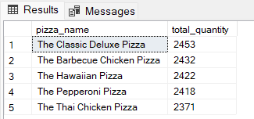

**K. Bottom 5 best sellers by quantity**

Select Top 5 pizza_name,sum(quantity) as total_quantity

from pizza_sales

Group by pizza_name

Order by total_quantity ;

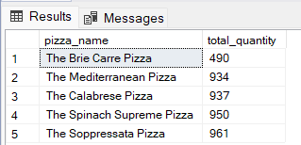

**L. Top 5 best sellers by Orders**

Select Top 5 pizza_name,Count(distinct(order_id)) as total_Orders

from pizza_sales

Group by pizza_name

Order by total_Orders desc;

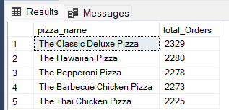

**M. Bottom 5 best sellers by Orders**

Select Top 5 pizza_name,Count(distinct(order_id)) as total_Orders

from pizza_sales

Group by pizza_name

Order by total_Orders ;

